**Monster Defense**

This is an upgraded version of the game Tower Defense. In this game, there are 5 good green monsters are enjoying the cookie. However, smell of the cookie is attracting all the bugs. If bugs reach to the cookie, they will kill those 5 good green monsters and eat the cookie. To protect those green good monsters and the cookie, other friend monsters are willing to help and kill the bugs before they can reach to the cookie.

**User Manual**

There are total of 3 levels which has two different types of bugs. Red ones are slower and easy to kill while blue one are faster and harder to kill. Here are some key points about how to play:

* Each level starts with 1000 gold. Player gets more gold by killing bugs
* There are specified spots and player can only put monsters on those spots
* There are three different monsters. Player can click on monsters to upgrade them if the player has enough gold and monsters are not fully upgraded to level 3.
* First monster costs 200 gold. The next upgrade costs 110 and the last one costs 120 extra gold.
* Each level has 5 health. If the bug reaches to the cookie, it will kill one monster and the player will lose one health.
* Player only gets 10 seconds until the next wave. As the level increases, along with waves, the wave time decreases to make the levels harder.
* Player can press N to go the next level and P to go to the previous level.
* If player loses all the health, the game will restart.

Here are some screenshots from the game:

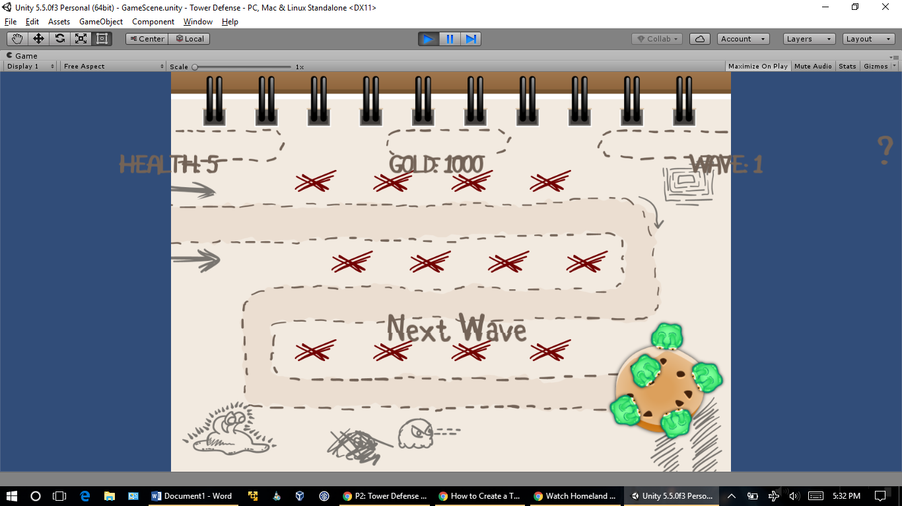

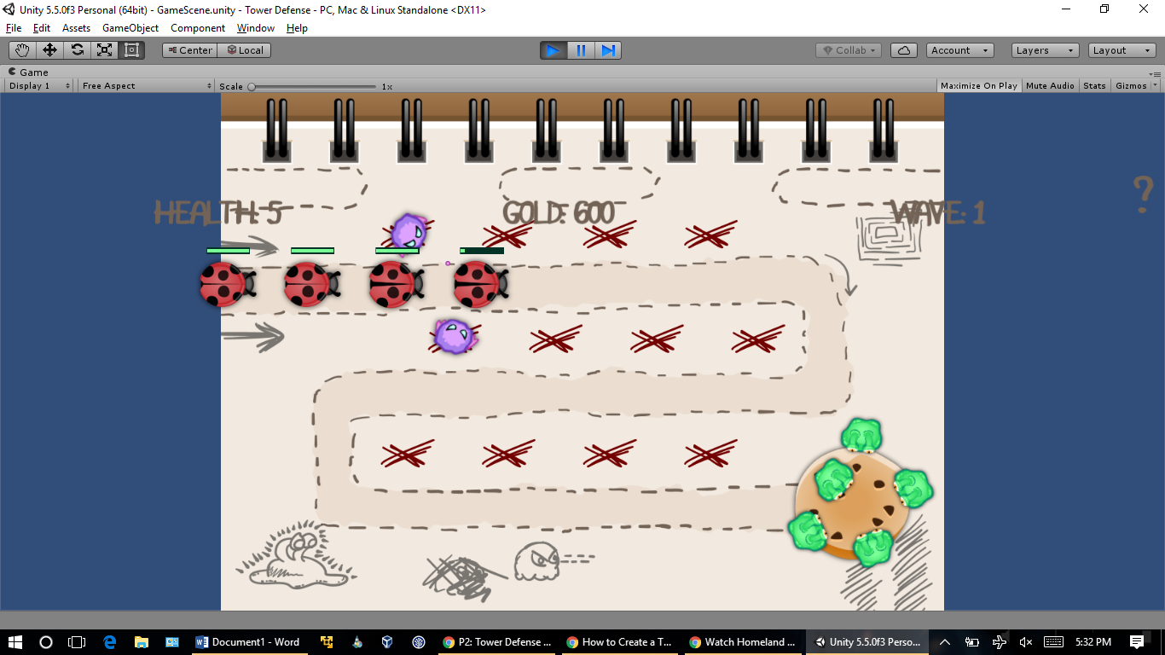

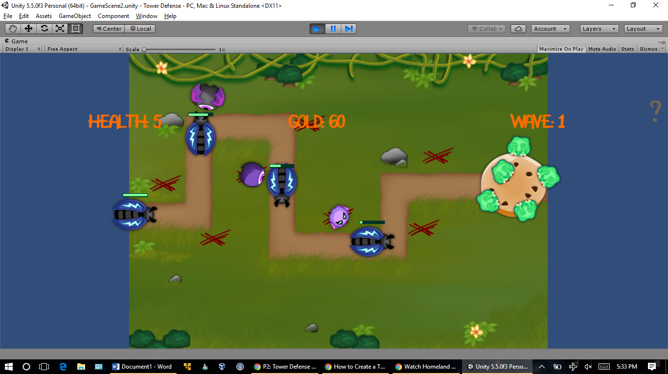

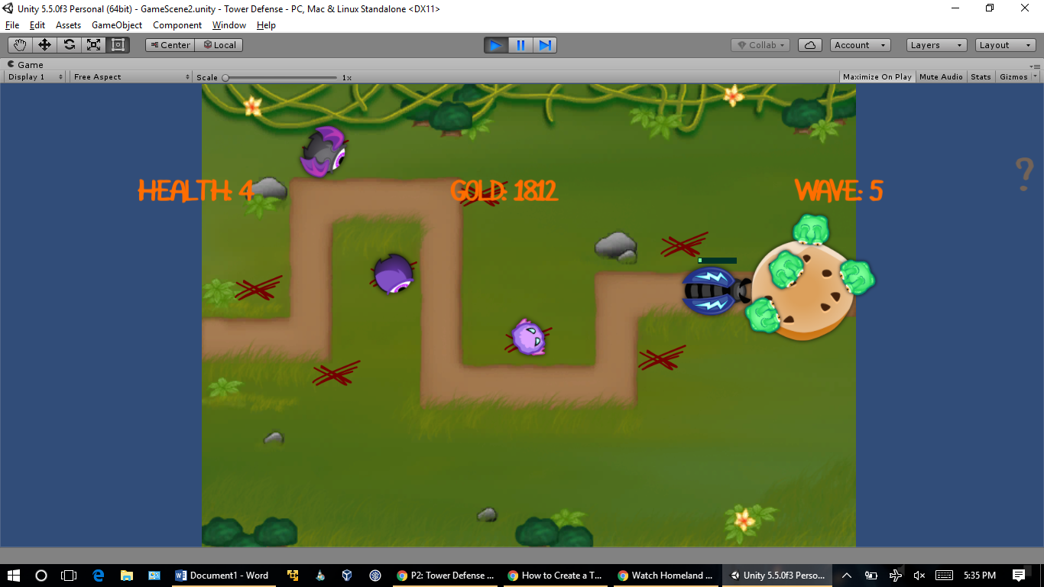

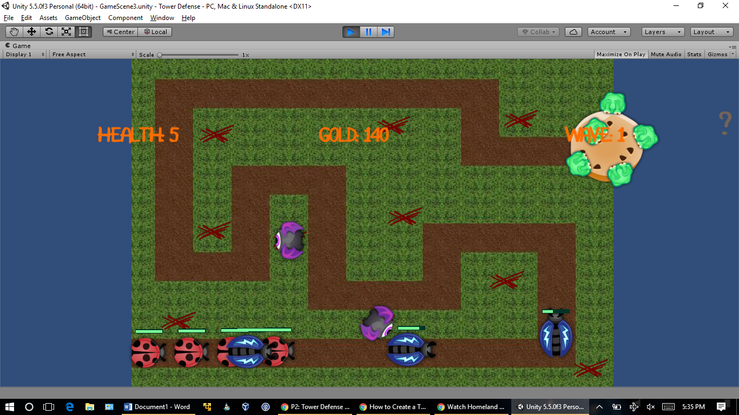

**Game Experience**

This time, I switched it to Unity from GameMaker as I have more experience in that and I want to get used to it before the last two project starts. It was fairly easy as there were many examples online. The one specifically helped me out a lot was <https://www.raywenderlich.com/107525/create-tower-defense-game-unity-part-1>. It took me a while to get the idea and getting started, but once I got it, I was able to finish the project in few days. There weren’t many challenges and I want to keep using Unity for next upcoming projects since there is more help out there and I am not limited to functionalities like I was in GameMaker.